17” x 22” poster

1. Team members
2. Design opportunity and the problems that exist
   * Need to accommodate different groups that are eating, working solo, working in groups
   * Insufficient resources — tables, outlets, chairs, etc
   * Possible stakeholders: students, administrators, faculty, restaurant workers
3. Steps of research protocol
   * Rohr Commons in Tepper Quad
   * Focusing on how **students** utilize the space
   * Working vs. eating space
   * Groups vs. solo
   * Resources (outlets, tables, chairs, etc.)
4. Methods employed and participants studied
   * Online survey
     + 48 responses over 1 week
     + 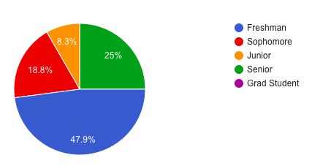
     + Variety of majors: Engineering, Physics, Drama, Business, CS, IS, Biology
     + If you don’t go to the Tepper Quad, why not? Where else do you go and why?
     + If you do, what do you use the space for?
     + What are the biggest issues/annoyances that you face in this area?
     + To what extent do these hinder productivity and enjoyment?
     + What do you currently enjoy about this space? What do you wish this space had?
   * Interactive posters
     + Draw what your table looks like
     + Draw a tick to indicate how long it took you to get to this seat since entering the space
     + Draw a circle indicating how much personal space you feel like you have
     + Put down ~20 posters total (both rounds) in Rohr Commons, were able to collect 10 filled out ones over 2-3 days
   * Guerilla interviews
     + How are you utilizing the space?
     + If this entire area was available, which table would you choose and why?
     + If you were eating/working in groups/solo, would you choose the same table?
     + What are the largest issues/annoyances you face when in Rohr Commons?
     + What are your favorite parts about Rohr Commons?
     + Would you be willing to share a table with a stranger?
       - If no, why not?
       - What issues do you anticipate with sharing with a stranger?
       - How would you communicate you’re willing to share a table?
     + Any other thoughts?
     + 15 interviews over 2-3 days
       - Students freshmen to senior (1 grad student)
       - 1 person who works at tazza
5. Research findings
   * Survey
     + 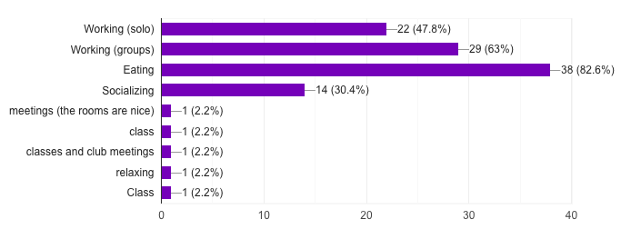
     + 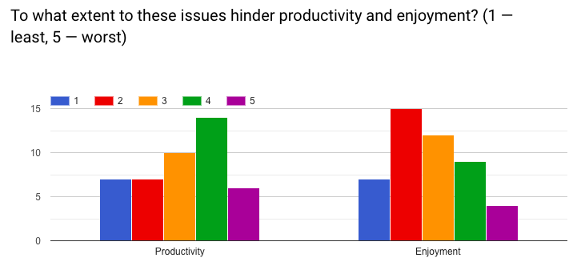
     + Biggest issues:
       - Too crowded/inefficient seating (people to seating ratio)
       - Not enough tables and seating
       - Outlets
       - Noisy
       - Misc (Tables are dirty)
     + Biggest pros:
       - Open space, light, modern architecture
   * Posters
     + People can find tables within 1-5 minutes or 15-30 minutes
     + A lot of people eating (and often also working) in groups
     + Generally feel like there is a lot of personal space? (hard to analyze)
   * Interviews
     + A lot of people use the space for *both* working and eating (if anything, just eating)
     + Mixed preferences for tables
       - Some people prefer high tables to work by themselves, others prefer for groups
       - Most people prefer the lower individual tables when working by themselves
       - Most like being on edges/away from a lot of people (1 or 2 liked being in the middle surrounded by people)
     + Biggest issues are noise and crowding
     + People like the openness of the space and that it serves as a good place to both work and eat
6. Proposal of redesign based on research discoveries
   * ~~Bigger low tables (up to 6-8 people for group project workers)~~
     + ~~Not getting rid of tall tables ⇒ not really needed~~
   * More outlet stands connected to each other (or outlets integrated into tables)

**Primary Problem: Inefficient seating**

1. Shaping a space’s culture / environment: promoting sharing of tables
2. Shaping physical space / environment: manipulating current physical tables

**Solutions:**

1. Stranger sharing system?
   1. Small notes from tepper quad admin encouraging users to share tables
      1. On napkin holders
      2. On a placard next to cash register when you pay
   2. Larger tables so there’s more space ?
   3. Tab flush with table to suggest open to sharing vs not open to sharing
   4. Posters on pillars when program is first implemented to bring attention to new concept ?
2. More tables
   1. Single long tables (chairs on one side) along the back wall of the trash area; designated locations for single workers
   2. More tables densely located around Tazza end edges of the Commons (preferred seating area, helps with volume control)
   3. Adding more tables
      1. Square → allows for pushing together for larger groups
         1. Manipulating space so that it suits user’s needs